Configure Your Linode for Reverse DNS (rDNS)
Updated , by Linode
dns networking cloud manager linode platform

Computers use DNS to determine the IP address associated with a domain name. Reverse DNS lookup does the opposite by resolving an IP address to a designated domain name. You should always set the reverse DNS, even if your Linode hosts more than one domain.
Reverse DNS uses a pointer record (PTR) to match an IP address with a domain or subdomain. PTR records are generally set with a hosting provider, so reverse DNS is set in the Linode Cloud Manager.

Before You Begin
Before setting the reverse DNS for your Linode, configure your domain zone and DNS records through Linode’s DNS Manager. See our Introduction to DNS Records and Common DNS Configurations guides for more information about PTR and DNS.
Specifically, you will need to create an A record for the domain name (or subdomain) that you want to assign your reverse DNS to. The value of this A record should be the IP address that you’re setting up reverse DNS on.

Setting Reverse DNS
- Click on the Linodes link in the sidebar to access a list of all your Linodes.
- Select the Linode whose reverse DNS you would like to set up and click on its Networking tab.
- Find the IP address whose reverse DNS you would like to set up and click on its more options ellipsis. Then, select Edit RDNS from the dropdown menu.
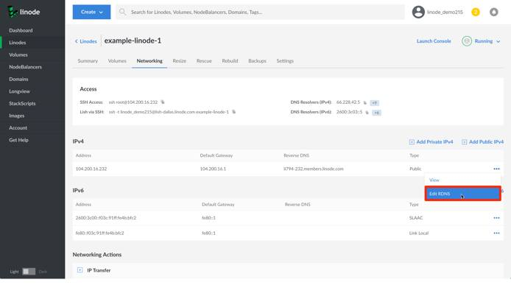
- In the Edit Reverse DNS field, add your Linode’s fully qualified domain name and click on the Save button.
Note
If you did not previously set up an A record for your domain that matches your Linode’s IP address, you will see an error like the following:
We were unable to perform a lookup for 'example.com' at this time.
You may also see this error if you very recently created your A record, as it can take some time for your DNS changes to propagate.
- You should now see the domain name you entered listed under the Reverse DNS column.
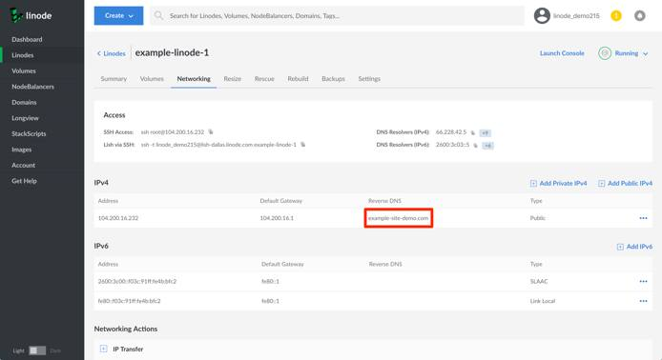
Note
If you want to set up reverse DNS for both the IPv4 and IPv6 addresses, you can perform the same steps for the IPv6 address.

